English 109 Introductory Essay

Your introductory essay should answer the following questions:

- What kind of writing have you done in the past? What are things that you enjoy about writing? What are things that you dislike?

- What skills have you worked on in writing classes in High School? How do you imagine that you will use those skills in this class or at other classes at the University of Washington? Do you think that you will need to adapt these skills in this new educational environment?

- How do you approach reading new texts? What strategies do you use to understand a text that is challenging?

This essay will not be graded, but will help me to figure out what skills to focus on during our class time together

This essay is due tomorrow, 9/25, and will be typed, double-spaced, printed, and stapled. Please include your name, the date, and the class.

Short Assignment #1- So, I made you a mix…

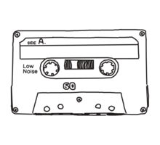

“The times you lived through, the people you shared those times with — nothing brings it all to life like an old mix tape. It does a better job of storing up memories than actual brain tissue can do. Every mix tape tells a story. Put them together, and they can add up to the story of a life.”
― Rob Sheffield, Love is a Mix Tape

There’s only one thing that really cements your status as an awesome person worth knowing. And that thing is the mix. Mix tape, mix CD, Spotify playlist, whatever is your jam. So this is your opportunity to introduce yourself to me and also to stretch out and recover your voice as a writer after the long summer after high school.

The assignment

-Choose three songs. List the name of the artist and the name of the song.

-For each song, please write a paragraph (around 250 words) explaining (to me) why you are using this song to introduce yourself.

-In your paragraph, you may refer to the lyrics of the song, to the visual language of the music video, to an event in your own life in which you listened to the song, to people that you associate with this song… Bring in any evidence that connects this song to you. Set the scene, tell the story, and just make sure that you are being specific and clear about why you have included this song in your mix.

Remember

This assignment, the writing part at least, is an exercise in expressing yourself as you are. Don’t worry about adopting some “writerly” tone or trying to sound “academic” or “collegiate” (whatever those words might mean). I want you to practice writing in your own voice about your own life. This is the first real skill to practice in college. So here’s your chance!

Format
I will walk you through the formatting for this assignment in class. Don’t worry.

Due: Tuesday, 9/30 before 9AM on Canvas
SA2: Summary + Response of Gerald Graff’s “Hidden Intellectualism”
Think about one of your non-academic interests—something that reveals your “hidden intellectualism.” This can be just about anything you spend substantial time thinking about, in ways that are (as Graff says) "reflective and analytical." In this essay, explore why and how this interest showcases your hidden intellectualism, and how yours relates (or doesn’t) to Graff’s. In other words, put yourself “in conversation” with Graff’s essay.
Some guiding questions to consider (you don't need to answer all of these): How well does your non-academic interest provide you with intellectual skills that are translatable to academic contexts? What are those skills? Do you think your high school or college "missed opportunities" to tap into that interest in order to engage you more deeply in academic intellectualism? Do you feel the same divide as Graff between academic intellectual culture and the culture of your "hidden" intellectual interest? What do you get from your "hidden" intellectual interest that school may not provide, and vice versa? How would you suggest that teachers support your own interests in the classroom in order to better engage you in your learning?
Your paper will need to include:
A brief summary of Graff’s essay (of about a half-page), so that your reader understands the key ideas you are responding to. (This will be a revision of the summary you wrote in class!)
Your response (between 1 and 2 full pages), including at least one quote from Graff. Be sure to "frame" the quote--explain it for your reader, and analyze how it relates to your response.
In your paper, I'll be looking for:
- A summary that explains Graff's key ideas clearly and is clearly written with your own response in mind (sets up your "I say")
- A thoughtful response that demonstrates an understanding of Graff's essay and the concept of "hidden intellectualism"
- Effective quote integration and sufficient quote analysis
Format: Between 1 1/2 to 2 1/2 pages, double-spaced in Times New Roman font with 1-inch margins.

Short Assignment #3- A Really Bad Review

By now, you have all identified something that you really, really hate. It might be a movie, a band, a TV show, a song, an actor, a food, a team—just some aspect of your pop culture life that you really cannot stand. Now, you’re going to expand your short review from homework into a longer review that examines other perspectives on the bane of your existence. You’re going to write a really bad review.

To do this, you must find a source (articles/blog posts/tweets/etc.) from either side of the issue. One source must agree with you and also hate your subject. The other must defend your subject or just really like it.

What to include:
- A revision of your original review. You will expand this review and add more evidence or examples for why you hate your subject.
- A very brief summary of your two sources. Include all the necessary information including the title (if there is one), the author’s name, and where you found the source.
- Two properly formatted quote sandwiches. Introduce the quote/context/argument, properly integrate the quote itself, and then speak back to it—why do you agree or disagree and how does this quote support your argument that your subject is the worst?

Note: You may include up to two logical fallacies in your review. However, you must identify these logical fallacies at the end of your paper and tell me why you used them. Use them wisely! If I find more than two logical fallacies, I will ask you to revise them out for the final version of your review.

Format: 12pt, Times New Roman, double-spaces, 1”margins. 1-2 pages (though I won’t dock you any points if it ends up being a bit longer).

Short Assignment #4- Rhetorical Analysis of Roxane Gay’s “When Less is More”

For this paper, please use your own reading journal and our in-class discussion to write a rhetorical analysis of Roxane Gay’s “When Less is More.” This will be a rhetorical analysis written for our classroom audience. Take the essay apart to show how her argument is put together and then take a stance on whether or not her argument is effective. Use specific details (paraphrase, quotations) from the text as evidence to support your analysis and your claim.
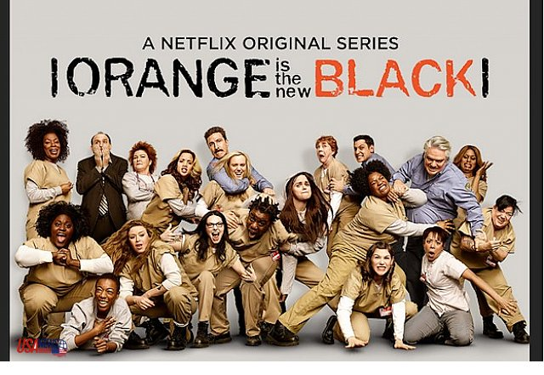

Answer the following questions in your essay:
- What is Gay’s situation?
- What is her purpose?
- What is her main claim? You may also cite important supporting claims.
- What audience is Gay writing for?
- How is she trying to impact her reader? What type of claim is she making?
- Does she use logos, pathos, ethos in her argument? How does she use these appeals?
- Make your own claim about how well Gay’s argument works: Is her argument effective for you as her reader? Does her argument resonate with your personal experience with representation in pop culture? Even if you do not agree with her argument, take this opportunity to engage with the stakes of what Roxane Gay has argued in her essay. Save this for the last paragraph after you have finished your analysis of the text.
Format
2-3 pages, 12 pt Times New Roman, double-spaced, 1-inch margins, MLA format with a Works Cited page including Gay’s essay.

Major Paper – Reading Smoke Signals
You will develop your own persuasive claim that integrates evidence from your reading on Alexie to answer any (or several) of the following questions:
- What is the importance of storytelling in the film? How does the film portray memories as a part of storytelling?
- How does the film portray family? What do Thomas and Victor think of Arnold? Why is this story an important story for Alexie and his characters to tell?
- How does Alexie use humor? What issues does this humor relate to?
- How does the film respond to stereotypes about Native Americans?
- How does Alexie use pop culture references to resist cultural assumptions about Native Americans?
- How does the film differ from the short story? Why do you think Alexie made these choices to adapt the story? Is the film made stronger from these changes?
- Smoke Signals is one of the first films produced by a Native American writer, director, and cast. Why is this important to Alexie? How can you see this influence on the film and its representation of life on the reservation (and beyond it)?
Expectations
- Develop a persuasive claim in response to the focused question and establish stakes that are rooted in your analysis of the texts you use to support your answer.
- Synthesize, or summarize and connect, the ideas presented in the texts we have read as they connect to your claim.
- Select and include properly MLA formatted quotes and paraphrases from at least two readings and explain their importance in support of your claim.
- Write in the genre of an academic paper intended for an audience of your instructor and your peers in this classroom.
Format
4-6 pages, 12 pt Times New Roman, double-spaced, 1-inch margins. MLA Works Cited Page attached.

English 109 Portfolio

The portfolio will consist of three revised papers. At least one paper must be your major paper. In addition, you will write a reflection on how your work this quarter demonstrates the learning goals for 109.

Your reflection will consist of three parts.
- An introduction. Like an academic paper, your introduction should set up expectations for the reader. What are we about to read? What should we look for? What are you going to argue about your writing?

- A body.
-Make a claim about how you are meeting each goal while using specific evidence from your revised papers to support that claim.
-You should answer these questions: What did you do in these papers to demonstrate the learning of the course? What choices did you make as a writer and WHY did these choices make your writing effective?
-You can draw from: your own work (outlines, class notes, drafts, and final papers); commentary received in peer review or seminar groups (conversation, worksheets, margin notes, class discussion); or individual paper responses from me on papers/in conferences.
-You should be quoting and analyzing your own work, as you would any academic source.

- A conclusion: This is your chance to say whatever last lingering things you’d like to say to me, about yourself as a writer, and/or about this class in general. Be sure that your conclusion articulates the overall stakes of your writing. What skills will you take with you to English 110, your other classes at UW, or into the future? You might say here which skills you would like to continue developing in English 110!
Keep in mind that the minimum length for an “acceptable” reflection is 2 double spaced-pages; good, strong, and outstanding reflections will be longer and more metacognitive.

