Chapter 1
Introduction to Expository Writing
at the University of Washington
Overview of Orientation Materials …..1-1
How are AP Classes Different From English 131 Classes?.....................................1-1
Sample English Literature AP Questions and Answers……………………………...1-2
Sample English 131 Major Paper Assignments………………………………………..1-7

Welcome to the Expository Writing Program (EWP) at the University of Washington. As an English 131 instructor, you will be embarking on an exciting and challenging teaching adventure; this manual is intended to guide you as you develop the course content, as well as help you understand the philosophies of writing and teaching that this program encompasses. Ideally, this manual will provide practical suggestions on ways to meet the pedagogical challenges particular to teaching English 131. We hope that you will read these materials first as an overview of the course you are about to teach, but we also hope that you will return to these materials to challenge and broaden your pedagogical approaches to writing instruction as you continue to teach this and other courses through UWHS.

Overview of Orientation Materials
To support you in your orientation to teaching in the Expository Writing Program, there are two main resources:
- This Instructors’ Manual, designed to cover the basic elements of teaching a course in composition, with a focus on providing practical information and advice.
- The EWP Website, including pages for students and instructors (password protected). Instructor pages include policies governing EWP instructors, sample teaching materials, department resources, campus resources, and more.
instructor pages: http://depts.washington.edu/engl/ewp/instructors
username: instructor password: portfolios

How Are AP Classes Different From English 131 Classes?
In the past students had been allowed to gain an exemption from composition credit with a “3” score on the AP Literature or Composition exams. However, AP credit no longer exempts students from taking the Composition credit at the UW (and many other universities). Why? While some students in AP classes may indeed have had a writing intensive course, more often, AP English courses are taught as literature courses and not writing courses, even though the College Board claims otherwise. Furthermore, the essays produced for the national essay exam tell us very little about how they might perform in our classrooms. The AP exam formats are 20 and 40 minutes in length and typically don’t ask students to work with texts, other than a brief literary text, usually a poem. We don’t know 1) if the student can perform complex, close readings of nonfiction texts, 2) if they can integrate several different perspectives on the same text, 3) if they can apply a concept derived from their readings to another set of texts, or 4) if they are knowledgeable about their own writing process. Finally, as all AP tests are assessed on a bell curve, the “3” score represents an average performance. For an exemption, we believe something better than the average is necessary.

Sample English Literature AP Exam Questions & Answers
The following essay prompts and essays are taken from the College Board’s Advanced Placement web site (http://www.collegeboard.org/ap/english). These tests are a fair indication of the kind of writing that is successful at the high school level. The challenge in teaching English 131 is not to dismiss the importance of the necessary foundational skills students are taught in high school classrooms, but to enable students to develop these skills – such as summarizing, interpretation, using literary terms, comparing/contrasting - in order to produce more complex, argumentative papers that emerge from critical engagement with a variety of primary and secondary materials – in short, in order to produce writing that will be successful at the college level.
Below are questions from the 2001 AP exam, along with samples of student responses to them and AP evaluations. Following these AP materials are examples of 131 assignments. The contrast between the two should give you an idea of the shift in expectations that students face when they begin college. Once you’ve read the question, you can take a look at the guidelines used to score the question, two sample student responses from actual exam booklets, and a brief explanation of why the responses earned the scores they did.
When you read the sample student essays (which were taken directly from actual student exam booklets), keep in mind that they were written under examination conditions and within strict time limits; in short, they will be less polished than if they had been developed at home, edited, and carefully presented. Faculty consultants (the people who score the AP Exams) take all these circumstances into account; they have been trained to look at the essays holistically and to judge overall quality rather than to attempt to divide the essay into content and style or to count errors.

AP English Literature and Composition
Free-Response Questions

suggested time—40 minutes.
This question counts as one-third of the total essay-section score.

Read the following two poems very carefully, noting that the second includes an allusion to the first. Then write a well-organized essay in which you discuss their similarities and differences. In your essay, be sure to consider both theme and style.

I. Bright Star

Bright star! would I were steadfast as thou art --
Not in lone splendor hung aloft the night,
And watching, with eternal lids apart,
Like nature’s patient, sleepless Eremite*
The moving waters at their priest-like task
Of pure ablution round earth’s human shores,
Or gazing on the new soft-fallen mask
Of snow upon the mountains and the moors--
No -- yet still steadfast, still unchangeable,
Pillowed upon my fair love’s ripening breast,
To feel for ever its soft fall and swell,
Awake for ever in a sweet unrest,
Still, still to hear her tender-taken breath,
And so live ever -- or else swoon to death.
—John Keats
*hermit

II. Choose Something Like a Star

O Star (the fairest one in sight),
We grant your loftiness the right
To some obscurity of cloud --
It will not do to say of night,
(5) Since dark is what brings out your light.
Some mystery becomes the proud.
But to be wholly taciturn
In your reserve is not allowed.
Say something to us we can learn
(10) By heart and when alone repeat.
Say something! And it says, ‘I burn.’
But say with what degree of heat.
Talk Fahrenheit, talk Centigrade.
Use Language we can comprehend.
(15) Tell us what elements you blend.
It gives us strangely little aid,
But does tell something in the end.
And steadfast as Keats’ Eremite,
Not even stooping from its sphere,

(20) It asks a little of us here.
It asks of us a certain height,
So when at times the mob is swayed
To carry praise or blame too far,
We may choose something like a star
To stay our minds on and be staid.
—Robert Frost*

Sample Free-Response Student Essay #1
Keats “Bright Star” and Frost’s “Choose Something Like a Star” although similar in their address to a star differ in form, tone and theme. The latter contains an illusion to the former which brings Keats’ themes into the poem. In order to compare these poems it is necessary to look carefully at their themes and constructions. “Bright Star” is a sonnet in traditional iambic pentameter. Its tone is elegiac as it celebrates the woman’s beauty and his love for her in his plea for steadfastness. The poem opens with an apostrophe to the star which calls our attention to his plea. The verbs “would” and “were” indicate his wish to be like the star whom he addresses as “thou.” The star is “hung” in the night, a pleasant image, and he uses a simile to compare it with Eremite, a hermit, who presumably sat apart from the world watching. The eyelids of this star (the star is given anthropomorphic qualities) are eternally apart -- always watching, “patiently” and “sleeplessly.” Keats then enumerates what this star watches. It watches water -- which is also steadfast as indicated by the comparison “priest-like.” The waters that surround the land Keats says are performing ablutions or cleansings and blessings on the land. The star also gazes upon the snow. He uses the metaphor of snow as a “mask” (more personification) as it hides the mountains and moors. The “m” alliteration emphasizes the falling of the snow. The repetition of “of” underlines the parallel structure and idea of the two scenes the star regards. The rhythm of this 2nd quatrain is slow and peaceful like the scene. Then Keats puts a “No -- “ which interrupts this peaceful rhythm; he does not want to look at pastoral scenery but at his lover. The “still steadfast, still unchangeable” emphasizes the fact that this constancy is similar to that of the star regarding the earth. The poet wishes to be lying on his lover’s breast which he implies is like a pillow and describes as “ripening” which emphasizes her fertility. Line 11 has a rhythm of a “fall and swell” like her breathing. He will be in a state of “unrest”, yet a happy one. The repetition of “still” underlines his intense desire and the “t” alliteration the tenderness of her breath. The final line sets up a contrast and the hyphen divides it. He will live forever this way, or else he will die in a “swoon” -- a faintness of overwhelming love. Either way he spends eternity faithful and steadfast to his lover. The rhyme in the final 2 lines adds to his summing-up quality of the couplet where he expresses his main theme -- to be as steadfast to her as a “bright star” is to the countryside.

Frost’s poem is quite different. The form is a bit freer, the poem is written in 25 lines of octosyllables with a conversational tone and a varying rhyme scheme. Frost too looks to the star to be steadfast, although in his case it is steadfast in moral or political beliefs, not in love. Similar to Keats’ poem, Frost begins with an apostrophe, and adds to it “(the fairest one in sight),” an humorous allusion to the child’s tale of wishing on the fairest star. Similarly, we derive a sort of wish from this star. He calls the star “your loftiness,” another humorous play on “your highness”, reflecting its physical and moral height above us. The poet as “we” (meaning all men) grants the star some anonymity, some aspects of a hermit isolated and watching the earth as he gives him “some obscurity of cloud.” Dark brings out the light -- this is a subtle indication that “we” see the star as it is the stoic steadfastness when something “dark” and evil is taking place on earth. But Frost does not allow the star to get away with saying nothing -- his “position” requires his contributing advice. Frost implores him to say something catchy that we can cling to -- and the run on line emphasizes the energy of this begging. “Say something!” (9) disrupts the rhythm and adds even more desperation to his plea. All the star says is “I burn.” Frost with a tongue-in-cheek tone implores him to add scientific details -- the kind humans like to deal with. He speaks of “Farenheit” and “Centigrade” like they are languages -- and capitalizes “Language” for this purpose -- we understand facts. But it doesn’t really help that much, he says. In line 18 Frost changes to speaking of the star as “it” and alludes directly to Keats’ poem. Frost says that the star is like Keats’ Eremite, the star that steadfastly watched the goings-on on earth. In using this allusion Frost not only continues the “poetic tradition” but adds all the depth of meaning of Keats’ poem to his own. The star doesn’t want much of us -- only to stay above us. He says that “when the mob is swayed” or when social, political, or moral upheaval takes place and the norm is to be radical, the star likes being above it all, condescendingly regarding the earth. When this happens, we should “choose something like a star” and concentrate on it. In the final line the similarity between “stay” and “staid” emphasizes that we must emulate the star in being constant and moderate while society may revolve around us in social or political turmoil. This “staidness” is our key to survival like the stars’.

Therefore, one can see that these poems although similar in their title and central image of the star differ in their themes, form and treatment of the author’s ideas.

AP Scoring Commentary for Sample Student Essay #1
This essay, which received a score of 9 at the Reading, was one of the very best essays received for this poetry question. It is included here not to represent essays typical of those in the 8-9 [highest] range, but to show you a distinguished response, an example of what the most accomplished students are capable of writing on this examination. Also, it provides such a clear and accurate explanation that it can serve you as a reliable guide to the two poems on this question.

Reading an example of an outstanding essay should not discourage anyone, but rather motivate you to develop your own skills in writing and literary analysis so that your response to essay questions -- whether on the AP Examination or for any college course -- will reflect your best abilities. This essay, then, represents a goal -- a model of the heights it is possible for students to achieve. The poems are, after all, about stars.

The writer begins by taking all the requirements of the question into account, noting that although the poems are “similar in their address to a star,” they “differ in form, tone and theme.” Thus, the student addresses the tasks of discussing the poems’ similarities and differences and considering both theme and style. Throughout the essay the writer explains not only what, but how the poem says.

The essay is organized first into a discussion of Keats’ poem and then Frost’s; the discussion of each poem contains a carefully integrated analysis of style and content. The student explains how the forms of the poems differ; “Bright Star” is a traditional sonnet, but Frost’s poem is “freer” in form with “a varying rhyme scheme.” He or she also explains that the tone of the Keats poem is “elegiac”; Frost’s has “a conversational tone” that is even in places playful. Apt examples from the texts are used to support and illustrate all such assertions.

The student notes that both poems begin with an apostrophe to the star; both poems present the star as representing steadfastness. But the student also recognizes that in Keats’ poem, the speaker’s concern is being faithful to an individual -- steadfastness as fidelity in love; the speaker in Frost’s poem is concerned with being faithful to individual values -- steadfastness as fidelity to one’s own beliefs in spite of the current opinions of the “mob.”

This essay is not perfect; the explanation of the alliteration, for example, strains credulity, but it is characterized by remarkably perceptive and cogent comments. Well focused and precisely worded, the analysis is fully developed and fluently written.

Sample Free-Response Student Essay #2
Although both “Bright Star” by John Keats and “Choose Something Like a Star” by Robert Frost both address a star with a spirit of awe, the first uses formal diction to express a wish while the second uses informal diction and contains a lesson.

“Bright Star” contains lofty, formal kinds of words such as “thou art” and “splendor hung aloft” to show reverence toward the star. Keat’s specific word choices also contribute to the theme of the poem that man wishes happiness would last forever. Comparing the star to an eye with “eternal lids apart” brings to mind God, who is connected with eternity and happiness and the sky or heavens. The star is also compared with a hermit which brings to mind silence, holiness, and solemnity. The word “ripening” connotes life, and the speaker wishes to enjoy the best of life “forever.”

Robert Frost’s poem also address a star in the first fifteen lines, but the diction is informal. In plain, ordinary kinds of words, the speaker asks the star to “Say something to us that we can learn/By heart.” The speaker of this poem wants the star to tell the secret of its steadfastness, instead of just wishing to be like the star. Then in the last ten lines, this poem adds a lesson. Although the star seems to give “little aid,” it teaches the speaker “something in the end.” The speaker feels that just thinking of the noble star will help him to be steadfast and not to be swayed easily with the “mob.”

AP Scoring Commentary for Sample Student Essay #2
This essay was selected by the faculty consultants as a good example of a paper that merited a score of 6 on the 9-point scale. Note that in terms of the scoring guide, it discusses “somewhat narrowly the meaning of the poems.”

This is not a weak paper, nor is it poorly written. Its chief strength lies in the fact that the writer does show evidence that he or she understands the two poems. The writer sees the difference in “theme and style” of the poems and is able to discourse, even if thinly, about the speakers’ purposes: Keats’ poem expresses the “wish” that “happiness would last forever” while Frost’s poem “contains a lesson.”

These assertions are elaborated upon through a series of references to the texts of the poems that focuses largely on “formal” and “informal” diction. Frost’s idea of “steadfastness” against the sway of the “mob” or unruly emotion is clearly grasped by the student, as is Keats’ wish to “enjoy the best of life forever.”

This is a competently written paper even though it may lack depth in analysis and polish in style. The student is an effective reader and writer, despite one or two glaring lapses. This is a good middle-range essay.

AP English Distribution of Grades for 2004
Percentage Earning Grade
Language Literature
Extremely Well Qualified (Exam grade of 5) 8.7 % 9.2 %
Well Qualified (Exam grade of 4) 17.8 % 21.3 %
Qualified (Exam grade of 3) 31.7 % 34.3 %
Possibly Qualified (Exam grade of 2) 33.0 % 27.4 %
No Recommendation (Exam grade of 1) 8.8 % 7.7 %
Mean Grade 2.85 2.97
Standard Deviation 1.09 1.08
Number of Candidates 198,514 239,493
Number of Schools 7,071 11,134
Number of Colleges 2,458 2,853

Sample English 131 Major Paper Assignments
To give you a sense of how the major papers in English 131 differ from writing for the AP exam (and the five-paragraph essays high school writers are so familiar with), on the following pages are examples of recent English 131 essay assignments, directly followed by a 131 student paper responding to that prompt.
When reading through the prompts and student papers, it may be helpful to consider the following questions:
- How are these essay topics different from the AP exam questions?
- What skills are students demonstrating? What specific learning outcomes for 131 (see Chapter 2) do these essays demonstrate?
- How successful are the students at completing the assignments?
- How do these examples compare to your expectations of college writers?

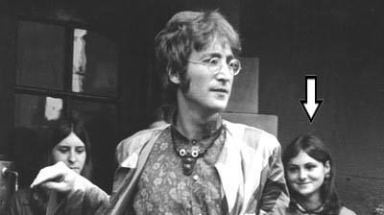
Our Revolutions
Of Culture
Major Paper 1
Draft Due: Tuesday, February 12th
Revision Due: Thursday, February 14th

“You say you want a revolution, well you know, we all want to change the world.”
- John Lennon

For your first major assignment, you will engage with a revolution that has materially impacted your life in some way. With the advent of the internet, more expressive music, movies, and other art, and the changing political climate of the late 20th and early 21st centuries, many components of our lives are in a state of dramatic change that is often the result of ideas suggested by a definable entity. To begin this assignment, you will need to choose an element from your own life that has impacted your life in a profound way. This can be a person, a place, an idea, an article of clothing (in Marjane Satrapi’s case) – anything so long as it is personally impacting. This should not be a figure whose revolutionary reputation is already established. Once you have chosen your revolutionary figure, you will begin a line of inquiry by exploring and compiling evidence of revolutionary behavior.

In the texts that we have discussed about revolution (King’s “Letter From Birmingham Jail,” Satrapi’s “The Veil,” and Scott-Heron’s “The Revolution Will Not Be Televised”), those who record the events of a revolution are often people who are involved with carrying out the revolution or are directly and profoundly affected by the outcome of the changes that have occurred in their societies. What compels these people to record the changes that take place in their lives? The purpose of this assignment is twofold:
- To get you to examine and make a claim about a revolutionary figure that has had an impact upon your life while demonstrating an understanding of the models of revolution from Acts of Inquiry.
- From there, you should assess why you felt compelled to act as the documentarian for this particular figure. And, because you are arguing for their relevance and inclusion in a text like Acts of Inquiry, you should consider the audience for this paper to be the editorial staff of that textbook (the staff includes instructors and administrators of English 131).

Ideas to Consider:
- What makes an idea, an action, or a place revolutionary?
- What is the relationship between the revolutionary figure and those who document the revolution?
- Who or what are the sources of your evidence? Can they be trusted to be objective? (If not, is their subjectivity lending itself to the revolutionary behavior of the figure you are researching?)
- In what ways does the revolutionary figure appeal for support? Does this public appeal actually make them more or less revolutionary?
- In what ways does the presentation of information through different genres affect the message of change?

Your paper should include:
- A complex claim about the revolutionary status of your figure
- Evidence that supports your claim (which must include at least one of the readings from Acts of Inquiry as well as personal reflective evidence). Remember you must have evidence in both halves of your paper
- An explanation of how the evidence supports your claim – it is up to you to make the connections between the evidence and your claim
- A discussion of why you chose this figure (when you could have chosen anybody/anything)

The Format:
Your paper should be 5-7 double-spaced pages with 1-inch margins in 12-point, Times New Roman font. Be sure to use MLA format for your in-text citations and your works cited page. Please bring 2 copies of your paper to class for peer review. Refer to the syllabus for the late paper policy.

The Outcomes:

English 131
Jeff Johnson
February 12th 2008
The Lack Thereof: Battling the Majority
Cancer is the second most common cause of death in the United States, and claims the lives of over half a million individuals each year (National Cancer Institute). The origin of the disease takes place in the uncontrollable division of abnormal cells. It can often spread to other parts of the body through the blood and the lymph structure. This can commonly cause different types of cancer to occur, such as Leukemia. The treatment of cancer generally includes chemotherapy, a method that utilizes different medications to kill cancerous cells, which often causes most patients to temporarily lose their hair. These conditions actually have little connection to my personal revolution. The only connection that can be formulated between the two is the assumption that I indeed am a cancer or leukemia patient due to my physical appearance. However, this is not the case. About a year ago, my dermatologist diagnosed me with a mild form of Alopecia, an auto-immune disease that results in the loss of one’s hair. After going through the process of trying different treatments, my diagnosis was changed to the most severe stage of Alopecia, Alopecia Universalis. As the name suggests, this advanced stage of the auto-immune disease causes the individual to lose absolutely all of their hair, extending to even the unnoticed places such as the nose and the eyelashes. I then went through the process of slow, but complete, hair loss. Though this experience would be tragic to a person of any gender, at any age, the fact that I am a female, and was, at the time, in my senior year of high school choosing not to hide behind a wig, created an even more difficult situation. As a result of this dramatic change and my life-altering decision to not wear a wig, I have found myself rebelling against the harsh standards that have been set forth for women and society as a whole in a country where the importance of appearance interjects itself into all aspects of one’s life.
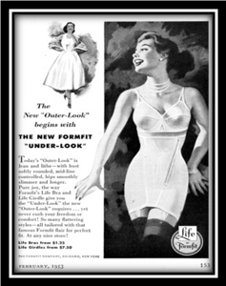
The public image of women is always transforming. If the women of the 1950s and the contemporary woman are compared, it is obvious that styles have changed over time. However, if the same women are analyzed more closely, similarities, not in fashion or occupation but in the definition of what a woman is supposed to be, can be formed. Placed below, in Figure 1, are two advertisements. The left one is from the 1950s and features an advertisement about undergarments for women. The picture featured on the right is a recent perfume advertisement. Though these images are blatantly different, it is the visual similarities between the two women that prove to be important. Both women have three main likenesses, thin proportional bodies, faces enhanced through the application of make-up, and full heads of healthy hair.


Fig. 1. The FormFit Company. Advertisement. Coronet Feb. 1953: 153. (Left)
Rochas. Advertisement. www.rochas.com. 2002. (Right)

These are the parameters that women in the American culture are told to follow. If a woman does not have all three components they are not considered to be normal and are expected to strive to reach this so called normality. My decision to wear a wig or not was a decision of whether I wanted to remain normal, whether I wanted the majority’s approval. Marjane Satrapi made a similar decision in The Veil. During the Iranian Revolution, the government reintroduced laws that forced women to wear the traditional, religious veil once again. She “didn’t know what to think about the veil. Deep down [she] was very religious but as a family [they] were very modern and avant-garde” (Satrapi 592). She was torn between two different identities, the society approved, rule following individual and the contemporary, rebellious individual. However, Satrapi found herself somewhere in between. Throughout my research on Alopecia, I have found a never-ending supply of women who want to hide their condition in any way possible, to continue to follow the public’s expectations. There are sites and foundations dedicated to aid women in the hunt for the perfect wig, testimonials on how realistic tattooing one’s eyebrows on can appear, and tips on how to apply make-up just right so to avoid any suspicion. All of these pathways are used to maintain the normality set forth by the American culture, just as wearing the veil would have followed through with what Satrapi was expected to do. Satrapi chose not to wear the veil because she felt as though it did not represent her faith; she could still be religious without having to conform to the traditional practices. In my decision, I was torn between the American approved identity and the self-approved identity. Wearing a wig to me means hiding who I truly am. I am more comfortable being bald than wearing a wig, and for this reason I felt that going bald was the better choice. Though my decision affects my daily life and I still have the desire to be considered relatively normal, I do not think that the public’s approval should have any say in such a monumental decision.
Women are not the only victims in the definition of normality. Society as a whole is affected. In this culture, hair has many representations. Health is one of the more significant symbols. The image of a completely bald individual, either male or female, can often bring about thoughts of illness. Just in the past twenty-four hours, I have had no less than two individuals, either out of curiosity or in of hopes finding someone that they can relate to, come up to me asking specifically about chemotherapy. This may seem like an odd occurrence to expect in the span of one’s day, but I have become accustomed to it. Though these events can be extremely frustrating and even more so irritating, I still find myself asking similar questions of others. I work at the cafes on campus and a few male individuals come to the stand quite frequently, both of which suffer from Alopecia Areata. If I had not been diagnosed with Alopecia, I would believe that they are going through either chemotherapy or some other treatment. This shows very simply how engrained the ideas of this culture can become and how easy it is to assume something about an individual when there is no real evidence at hand besides the ideas that the society has taught us.
If the Hollywood scene can be considered a fair representation of what is expected of society, then hair has become a marker of wealth and attractiveness. When I think of Hollywood and the effort they put into their appearance, the women of Hollywood are the only people that come to mind. The men, in my mind, have little to worry about besides the physical shape of their bodies; however, through my research I have found that this is defiantly not the case. Many individuals including actors such as Matthew McConaughey, Nicolas Cage, John Travolta, and Ben Affleck have similar issues to mine. All of these individuals deal with balding and have chosen to hide it like many people with Alopecia. The images below in Figure 2 are a series of pictures of John Travolta.
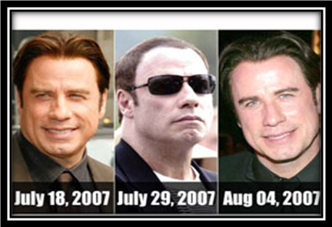
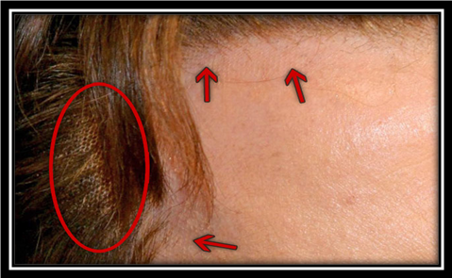

Fig. 2. FilmMagic/Getty. “John Travolta”. Photo. Travolta: What a Tangled Web He Weaves! 7 Aug. 2007. 10 Feb. 2008. <http://www.tmz.com/2007/08/07/travolta-what-a-tangled-web-he-weaves/>.
“John Travolta”. Photo. John Travolta. 10 Feb. 2008. 10 Feb. 2008. <http://www.education.makemeheal.com/index.php/Travolta,_John>.

On the left is an image that shows three different pictures of Travolta over the span of roughly a month. The photograph on the right is a close up of Travolta’s hairline and was captured at this year’s Oscar’s. As you can see in the picture on the left, Travolta appears to have impossible amounts of hair growth over the length of a week. The average growth rate for any given individual is only a half of an inch per month. This alone provides the evidence that Travolta uses some form of treatment to hide his hair loss. On the left is a very revealing image, showing that Travolta does in fact conceal his hair loss with something similar to a wig. Though male pattern baldness is just a fact of life, it seems that people in the lime light or in any position of wealth try to hide it as long as possible. This makes sense in a country and occupation where image is everything; it is an individual’s reputation and paycheck. These actions do not come without consequences, however. Due to the importance that these individuals place on their appearance, the public who is exposed to them everyday allows these views to influence their own. It may not affect everyone directly, but the majority certainly suffers from such standards. Hollywood is the reflection of the standards set forth by the American culture, and thus the rest of the population will follow in similar footsteps as those in Hollywood.
Throughout one’s daily life, the standards that the American culture projects are obvious. One cannot go grocery shopping or listen to the radio without being exposed to the propaganda of the next “Miracle Drug” or the next quick fixes for your little so-called “flaws”. As I have argued above, the American culture expects perfection. It expects one to follow the yellow brick road that it has set before them in the ultimate goal of killing individualism. Though hair is only a single brick along this road, it becomes a larger issue when it directly affects the individual. Being diagnosed with Alopecia has handed me the choice of whether I want to continue along that same road that generations behind me have or to cut a new path. Not wearing a wig was my decision to create a new way, a way to reclaim individualism. Even if the desire to follow the “norm”, the desire to follow the images portrayed in Hollywood, is present, it does not mean that one has to transform into exactly what the American culture says they should. America is defined as a melting pot of different cultures, and I believe it should remain that way.

Appendix A
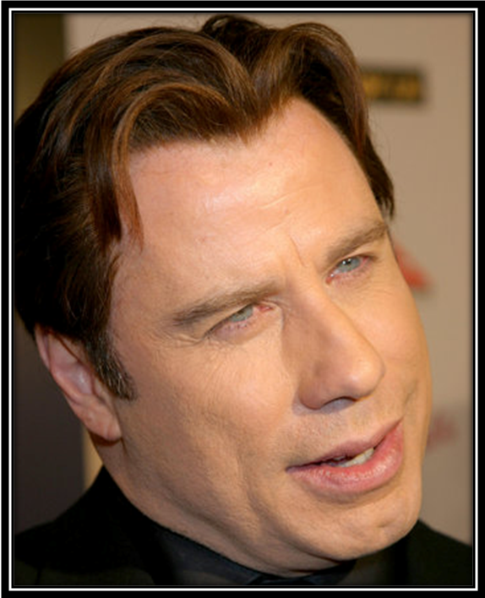
"John Travolta." Make Me Heal. 10 June 2007. MediaWiki. 10 Feb. 2008 <http://www.education.makemeheal.com/index.php/Travolta,_John>.

Works Cited
"Cancer:Question and Answers." National Cancer Institute. 10 Feb. 2008. The National Cancer Institute. 10 Feb. 2008 <http://www.cancer.gov/cancertopics/factsheet/Sites Types/general>.
Hawtin, Lucy. "Best Ad." 10 Feb. 2008. 7 Feb. 2008 <http://best- ad.blogspot.com/2007/09/beautiful ads.html>.
"John Travolta." Make Me Heal. 10 June 2007. MediaWiki. 10 Feb. 2008 <http://www.education.makemeheal.com/index.php/Travolta,_John>.
Rassman, Dr, William. "John Travolta's Hair Piece?" BaldingBlog (2006). 10 Feb. 2008 <http://www.baldingblog.com/2006/03/17/john-travoltas-hair-piece/>.
Satrapi, Marjane. “The Veil.” Acts of Inquiry. Eds. Angela Rousaville, et al. Boston: Bedford/St.Martins, 2008. 589-95.
"SECRETLY BALDING MOVIESTARS : Who is Wearing a Wig in Hollywood?" WWW.MOVIESTAR.NU. 10 Feb. 2008. 10 Feb. 2008
<http://www.moviestar.nu/articles/baldmoviestarsenglish.html>.
Tmz. "Travolta's Hair Weaves a Tangled Web." The Huffington Post. 10 Feb. 2008. 10 Feb. 2008 <http://www.huffingtonpost.com/2007/08/07/travoltas-hair-weaves-a- _n_59473.html?view=print>.
Wenn. "Movie/ TV News." The Internet Movie Database. 5 Sept. 2002. Amazon.Com. 10 Feb. 2008 <http://www.imdb.com/news/wenn/2002-09-05>.

Seeing and Being Seen in Seattle
Major Paper 1

With all the talk of ‘virtual this’ and ‘online that,’ I think it’s important for us to realize that place matters still.
– Tom Dobrowolsky, Urban Archives

In class, you were introduced to the Urban Archives, the only collection on the University of Washington Library website compiled by undergraduate students. For your last major paper of the quarter, you will take on the role of a member of the Urban Archives research team. To begin this paper, you will first need to pick a public space in Seattle to be the site of your research. You can pick a space on campus, in the University District, or anywhere else in Seattle that is of interest to you (such as a park, a shop, or a place of worship). Once you have chosen a space, you will need to spend some time visiting this space, observing how the space is used while paying particular attention to the types of texts that you find there (such as photographs, graffiti, videos, songs, advertisements, flyers, etc.).

The goal of this assignment is for you to see or “read” the space using the ideas in John Berger’s Ways of Seeing and/or Michel Foucault’s “Panopticism” as your theoretical lens. Just as we have done in class with the Katrina example, you should apply these ideas to a new context – in this case, the space and text you have chosen for your research. Essentially, what you are doing in this assignment is analyzing the ways in which people see and/or are seen in the space, and to what effect (the stakes).

In your paper, you should include: (1) a complex claim about the space, (2) visual evidence (photographs) and textual evidence (including at least one source in addition to Berger and/or Foucault) to support your claim, and (3) clearly articulated stakes.

The Format

Your response to this assignment should be 5-7 double-spaced pages with 1-inch margins and 12-point font. Make sure you use MLA format for your in-text citations and works cited page. You should bring 2 copies of your assignment to class for peer review.

Outcomes

Our Eyes Can Deceive
Our vision is one of our most widely used senses and often times we see things and make assumptions before we actually know what is going on. In his book “Ways of Seeing,” John Berger claims, “It is seeing which establishes our place in the surrounding world; we explain that world with words, but words can never undo the fact that we are surrounded by it” (155). Berger discusses how we first see things by putting ourselves in a world, and then after that we gain knowledge about it. Those who have little knowledge about a place can create assumptions, good or bad, through what they see and in general these assumptions are incorrect. Due to the assumptions about Mariner, the high school I attended, it has become a target for negative attention. Many people have come to believe that Mariner High School students are involved in gangs due to the increase in gang-related activities in an area that surrounds the high school in South Everett. This assumption by onlookers has left a dangerous and violent image on all Mariner students, and in turn labels Mariner, and the surrounding area, as an inferior and unsafe place to be.
Although there has been a rise in gang activity all throughout Everett, the area surrounding Mariner has received the most attention due to some larger-scale gang activities; one of which happened in September, just a few weeks into the school year. This story was reported by several news stations and newspapers throughout western Washington. A woman was driving into an apartment complex, across the street from Mariner, but was unable to proceed through the entrance because a group of 20 teenagers was blocking her way. When the woman honked her horn and signaled them to move out of the way, the group became irate and violent, pulling her our of the car by her hair. The group was broken up by police, but a few hours later when she went to pick up her children from daycare, just down the road from the apartment complex, she was confronted by the same group. This time they threw her up against the car and pavement numerous times, leaving her with lacerations and a black eye. This assault may, or may not, have been done by students from Mariner, but due to its close proximity to the school, Mariner High School drew the attention of the media.
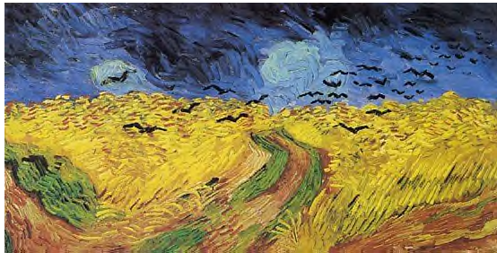
Although the facts about the case were properly reported, the way in which it was presented created a negative assumption about students at Mariner. Using Mariner as the background for live broadcasts of the event created an unpleasant image of Mariner, one that will stay with many viewers. In a section of his book, Berger introduces the idea that captions on images change the way a viewer may see the image, as in the case with the news reports. According to Berger, “It is hard to define exactly how the words have changed the image but undoubtedly they have. The image now illustrates the sentence” (171). He discusses how words alter the image’s meaning and allowing it to become a part of a different argument. The example he uses was a painting of birds flying out of a cornfield by Van Gogh (see image below). Without any captions a viewer may interpret that Van Gogh painted this picture as he saw, or had seen, it happen. Yet, when a caption is added to inform an audience, “This is the last picture that Van Gogh painted before he killed himself,” (171) the words change the way the viewer sees the painting. The painting is now depicted as Van Gogh’s thoughts about leaving the world, just as the birds are leaving the cornfield. The assault that happened outside of Mariner’s campus resulted in fear over the community due to the way the media reported the story:
A young mother is recovering from injuries and is now in hiding after she was yanked out of her car and beaten by a mob of teenagers. Neighbors say the mob of teenagers always hangs out around Mariner High School, and [the young woman] is afraid they will attack her again if they see her. (KOMO reporters)

After hearing this report, those who never saw the “mob of teenagers” involved with the assault will now associate any group of teenagers hanging out around Mariner as angry and potentially violent students.

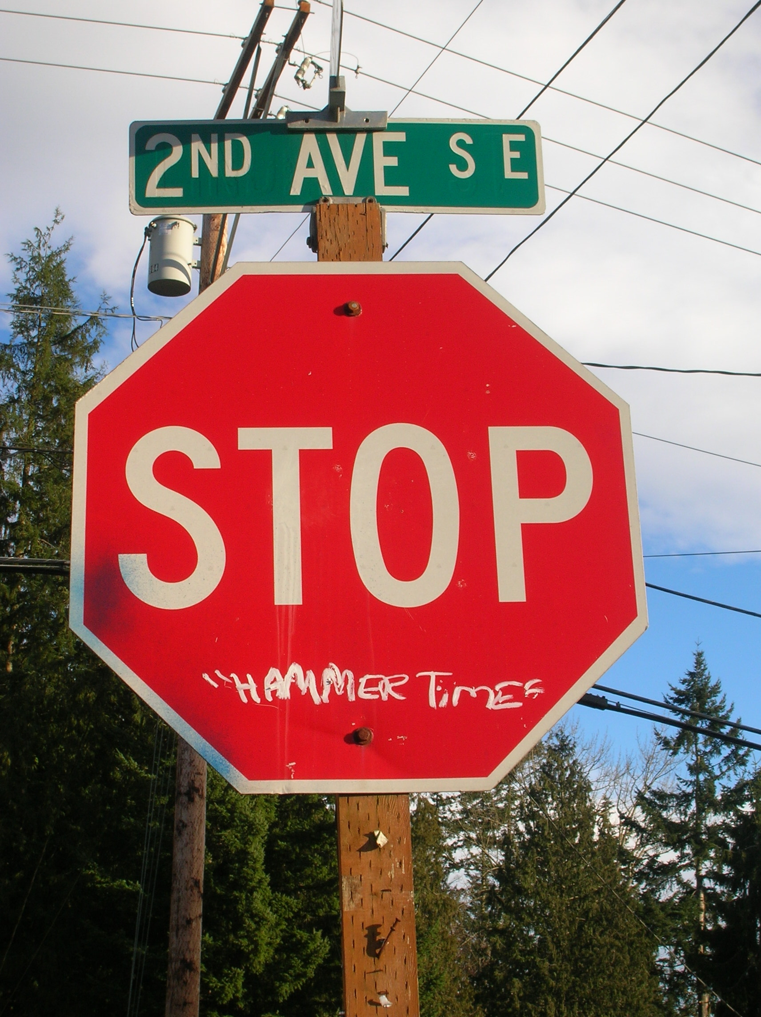
Aside from the violence, that may have gang ties, the area around Mariner has become a canvas for graffiti, which we commonly believe is there to represent gang boundaries and wars. Just as Berger suggests, “The way we see things is affected by what we know or what we believe” (155). Our entertainment these days gives an image of young gang members spraying graffiti on walls allowing our perception of graffiti to be shaped by what we have seen. But a recent article by Everett Herald’s reporters Jackson Holtz and Diana Hefley, reveals “About 80 percent of graffiti is called ‘tagger graffiti,’ often painted or drawn by teenagers.” This article suggests that a good share of the graffiti seen today is not gang-related, but rather, a new form of illegal art. As I walked around my neighborhood, graffiti seemed to overload the fences, electrical boxes, and street signs; some of the graffiti I found could possibly be gang-related (Image above taken by the author), whereas others I could tell were just tags (Right image taken by the author). Due to the excessive amounts of graffiti, the neighborhood is seen as a run down, suburban area amongst an urban city.


The neighborhood has tried to prevent crime from happening by stepping up surveillance through neighborhood watches, gated communities, posted signs, cameras and home security. Even though the community has done its best, crime continues to occur and more graffiti keeps showing up (Image to right, taken by the author). Surveillance is intended to discourage crime from happening by letting people know they are being watched. Although sometimes surveillance has no affect, like at Mariner. Cameras are clearly seen around the building, but this surveillance has not frightened these taggers and graffiti is now showing up on school property. The image on the left, taken by author, shows some graffiti on the backboard of the basketball hoop and in the top right corner of the building a camera is visible (through this picture the shadow of the camera is clearer). This graffiti is very visible around the school and to the observer it boosts the assumptions that the students at Mariner are delinquents.
Early last year, the Snohomish County Sheriff’s Office labeled the area around Mariner as a high crime rate area. Brian Alexander from The Seattle Times reported that statistics from 2005 showed that this one-square mile area accounted for five percent of Snohomish County emergency calls, averaging 36 calls a day. In March of 2006, Sheriff Rick Bart started a program called Operation Clean Sweep, designed to work with the community in cleaning up the neighborhood by stepping up the presence of county cops. For the kick off, “Snohomish County Sheriff’s Office lined up squad cars along 128th Street Southwest south of Everett with their lights flashing – a sign to would-be thieves, vandals and gang members plaguing the area that the sheriff was in town,” reported Alexander. Operation Clean Sweep has designated six deputy sheriffs to this one-square mile area, see Image 4 below, to decrease response time to emergency calls and increase the presence of power. This presence of power and the effects on others is discussed in Michael Foucault’s essay “Panopticism” where he states, “Bentham laid down the principle that power should be visible and unverifiable” (322). In this part of his essay, Foucault discusses that power must be unverifiable so that in the Panopticon a prisoner lives in fear he is always being watched, even though he may not be. This fear is not present among the criminals in the area because the deputy sheriffs assigned to this area are very visible and make themselves known. They are not unverifiable; their cars are well marked and most of the time they are assigned to posts.
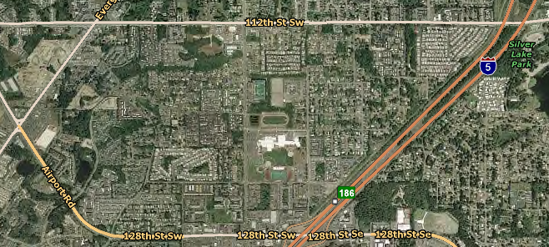
Image 4
Although the local neighborhood feels more safe with Operation Clean Sweep, others driving through, who may not know about the program, see the presence of police negatively. Every Wednesday, about 15 deputy sheriffs meet with Sheriff Rick Bart to discuss the previous week’s activities and the coming week’s goals. Unfortunately since Mariner is centrally located in the one-square mile area, they choose to meet in the parking lot around 2 pm, the time school gets out (Mariner is the large white building in Image 4). To drivers passing by, the scene of many police cars at the high school causes questions and assumptions as to why they are there. According to Berger these questions and assumptions arise because “we never look at just one thing; we are always looking at the relation between things and ourselves” (156). Berger claims that we are constantly looking around, connecting ourselves to what we see surrounding us. People from outside the area are comparing the mass presence of police around, and even at, Mariner to their neighborhood and local school. This comparison leads them to conclude that Mariner students can’t compare to those from other local high schools in education and in social situations.
Many people are seeing the negative events that are happening around Mariner and don’t have any knowledge about the positive effects that are occurring inside the building. Recently the school was remodeled to provide more classrooms inside the building, scrapping the junkie-looking portables that flooded the back of the school. The remodel also call for a paint color changed, Mariner previously had been known as the “pee-colored prison” and now sports a new neutral based blue and gray. Most of the funding for the remodel came from the Bill and Melinda Gates Foundation, which has adopted Mariner as one of 13 Achiever’s schools in Washington State. The aim of the Achiever’s schools is to create smaller classroom environments where students can obtain a personal relationship with a few teachers throughout their high school career, rather than being shuffled around. The foundation also offers quite a lot of scholarships for students who want to further their education. Athletics are also a big part of the improvements, with some of Mariner’s sports beginning to get respect from local sports writers. In the fall, one cross country runner placed 3rd in the state competition and was recognized as athlete of the week several times in The Everett Herald. Back in January, Mariner wrestling took on their rival and fellow district school, Kamiak. Both schools came into the ring undefeated and the match would decide who would take home the Wesco South Division title; Mariner came out on top. Most recent sport’s team in the media was the boy’s basketball team that made it to the state tournament at the Tacoma Dome.
Students who attend Mariner believe if others can continue to read positive things about their school, and not worry about what they see happening around the area, then they should become a respected school like others in the area. However, if we let the assumptions continue, that all Mariner High School students are delinquents, we will in the end be doing the students more harm than good. The students who wish to achieve in high school, working towards getting into college, will eventually go unrecognized due to the increase in hostility towards Mariner. On the other hand, those students who are just trying to finish high school may subject themselves to the negative stereotypes because they will have no support from the surrounding area. Rather than criticizing a troubled area, communities should support the effort to clean it up, so that the local residents feel that they are a part of a larger community and are well respected.

Works Cited

Alexander, Brian. “Operation Clean Sweep slowly gets results.”
Seattle Times 16 Jan. 2006:

Berger, John. “Ways of Seeing.” In Gail Stygall (ed.)
Reading Context (155-74). NY. Thomson Wadsworth, 2005

Foucault, Michael. “Panopticism.” In Gail Stygall (ed.)
Reading Context (322). NY. Thomson Wadsworth, 2005

Holtz, Jackson and Diana Hefley. “Graffiti gets close read.” Everett Herald
23 Jan. 2006: A1+.

KOMO Staff. “‘They just started stomping me, and stomping me’.”
29 Sept. 2006. 3 Feb. 2007 <http://www.komotv.com/news/local/4273211.html>

Van Gogh, Vincent. Wheatfield with Crows. 1890. Van Gogh Museum.
6 Feb. 2007 <http://www.mystudios.com/art/post/van-gogh/van-gogh-crows-wheatfield.jpg>

See Appendix A for a full photograph.

