Student B

Outcome 2: Teen Idol
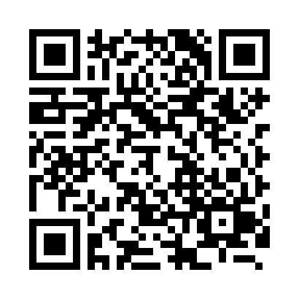
Scan this QR code for access to digital materials from this workshop, or go to “writing resources for students on the EWP website”
To work strategically with complex information in order to generate and support inquiry.
Hannah Montana quickly became the most popular Disney Channel program and the highest-rated series on basic cable. Miley used the success of Hannah to progress her own career goals, living the “Best of Both Worlds” as a superstar both on TV and in real life. Celebrity friends like Demi Lovato and Selena Gomez, as well as a romance withNick Jonas, helped Miley become the world’s most sought-after pop star. Her managers strategically made a deal with Hollywood Records which included multiple CD’s, tours, and a movie featuring alongside Liam Hemsworth - debatably the biggest teen heartthrob. Miley’s fan base continued to multiply and stretch across the globe as she released a new fashion line, numerous chart-topping songs, and Hannah became a TV staple.
Similar to Miley’s involvement in a variety of platforms, a strategic writer will include a variety of sources to support their argument. Having credible sources cited in a paper solidifies the writer’s conclusion by proving previous research and reputable people agree with the author. Outcome 2 teaches us the importance of evidence. Including evidence, and then clearly connecting the evidence to the main point of the essay is what convinces readers of the author’s claim.
In Short Assignment 4 we created an annotated bibliography. This assignment taught us the importance of citing evidence correctly, and how different pieces of information connect to the central claim.
For the assignment, I gathered five relevant sources, cited them in MLA format, and summarized how I would incorporate each perspective to further my own point. Although each source has a different author and claim, I was able to analyze each one for useful information which supports my own claim.

The following sub-points outline how SA 4 demonstrates my achievement of Outcome 2 during this quarter.
2.1 Reading, analyzing, and synthesizing a diverse range of texts and understanding the situations in which those texts are participating.
To comprehend the arguments of each source I had to understand how the author, context, and historical time period contributed to the bias and conclusion of each document. In SA 4 I included sources that were very different from each other. The authors varied from Amber Genuske, who is a ‘Multimedia Editor’ for the Huffington Post (Student B, SA 4 revised) to Tom McArthur, “a British linguist and editor of English Today” (Student B, SA 4 revised). Understanding how the author’s background affects their arguments helps contribute to comprehending the full claim of each document.

2.2 Using reading and writing strategies to craft research questions that explore and respond to complex ideas and situations.
The goal of my research was to discover why English became the dominant global language, and how it came to dominance. To answer these questions, I utilized the UW Library system by using key phrases like “British Empire”, “English in Science”, and “English in Global Business”. I researched sub points which I thought could help me understand why and how English is utilized around the world.

2.3 Gathering, evaluating, and making purposeful use of primary and secondary materials appropriate for the writing goals, audience, genre, and context.
SA 4 was a stepping stone to completing Major Paper 2, a research paper requiring at least five sources. My goal for SA 4 was to gather five documents that offered different perspectives, and to find both primary and secondary sources. I then analyzed these materials in a way which would be useful for including quotes in my upcoming essay. The TED Talk from Jay Walker contributed first-hand information from his work in China, and he,
“play[ed] a shocking clip of Chinese students” who “chant[ed] in response to a teacher that they are learning English because they ‘don’t want to let my country, parents, or self, down’” (Student B, SA 4 revised).
These summaries and quotes satisfy the requirements of SA 4, but also helped refine the focus of my essay by providing a plethora of information from a variety of authors about a common subject.

2.4 Creating a ‘conversation’—identifying and engaging with meaningful patterns across ideas, texts, experiences, and situations.
Although each document has a separate viewpoint, they share a common theme: the dominance of the English language. The document’s subjects vary from music, to the discovery of the Standard Model in physics, to the Chinese education system, yet all convince their readers of the importance of the English language. The Huffington Post “discusses why a large number of non-native English speakers sing in the English language” (Student B, SA 4 revised), solidifying the conclusions of Cambridge University Press, which states “English seems to be becoming the global language as a result of the massive socio-economic, cultural, and technological changes” (Student B, SA 4 revised). When read together, the texts further the claims of other authors.

2.5 Using citation styles appropriate for the genre and context.
In English 131 the accepted citation style is MLA. I cited all five sources included in SA 4 in alphabetical order in a Works Cited page, which is the standard citation style for a research paper. Included is an example of a citation of this style, which includes the url since I found this article online.
"Porzucki, Nina. “How Did English Become the Language of Science?” Public Radio International, GlobalPost, 6 Oct. 2014. www.pri.org/stories/2014-10-06/how-did-english-become-language-scienceLinks to an external site.Links to an external site.." (Student B, SA 4 revised)
Click here to Download FINAL - short assignment 4.docx

