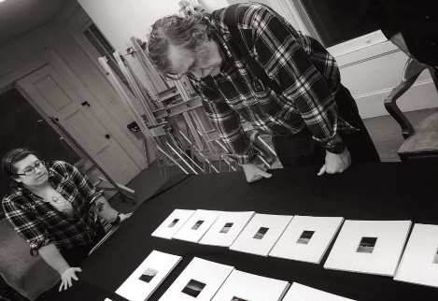
CRITIQUING (Outcome 4)
OUTCOME 4: To practice composing as a recursive, collaborative process and to develop flexible strategies for revising throughout the composition process. (Student D)
Even though the print has finished, the whole process hasn’t yet been complete. The final part of the photography process is the critique. At this point, my peers and photography teacher typically input their own feedback, examining ways I could improve on my photos to strengthen my work as a whole. I’m taking it all in so that I incorporate their ideas for the future, refining my composition choices and also re-visioning my work to continuously strive for improvement.
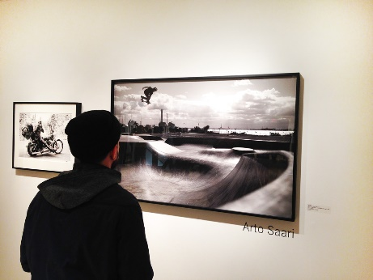
Outcome 4 encompasses this entire idea of revising, and through all three papers, SA2, SA4, and MP2.2, I realized how I elevated my work simply by incorporating peer and instructor feedback to revise and better my initial pieces. I always believe that you can never stop improving, and being able to critically see how I can strengthen my work is an invaluable asset both in and out of writing. Most people can easily get down the main ideas in the first draft or so, but oftentimes those initial works are not fully fleshed out. Through feedback, constant revision, and nuanced details for the most effective rhetorical situation, I’ve learned that I can always take it to the next step.

OUTCOME 4.1: Re-visioning
For all of my pieces, I engaged in various re-visioning techniques where I went back to my work to bring out the weaker parts that I initially had. I found value in this because by essentially going back for the second or third time, I didn’t have to focus on writing everything down from the start, but rather spotting holes or shortcomings that allowed me to polish the essays better.
In SA2, I revised my composer’s memo to address parts that I initially left out, such as why I put Marjane Satrapi’s name or left the “i” lowercase. I also re-brainstormed how I could have improved on the poster by considering adding symbols on the graphic. As for SA4, my annotated bibliography needed some more details for summaries of each source, so I went back to re-think and clarify on my ideas that were initially more general. Finally, for MP2.2 I made substantial revisions to my rhetorical grammar and sentence structure, so I spent a great deal of time working on how to restructure my phrasing to produce my intended effect.
OUTCOME 4.2: Utilizing constructive feedback
“I think it would help your argument of your own rhetorical effectiveness here to talk about how you placed Satrapi's name prominently on the poster” (Instructor Comment SA2).
Sometimes, having just one set of eyes isn’t enough. Especially after a certain amount of time, looking over the same work over again without a fresh perspective doesn’t typically sprout new ideas. That’s why instructor feedback was helpful, because I saw how I could improve my own ideas that I wrote, yet lacked to address them because it didn’t occur to me. From that comment, I incorporated My instructor's perspective and effectively added my thoughts on why the name placement was rhetorically effective, allowing me to developed a more nuanced memo for SA2.
OUTCOME 4.3: Refining compositional choices for desired rhetorical effects
All of my three pieces definitely incorporated refined composition choices for the desired audience and rhetorical effects. For SA2, I clarified who my audience was and why my choices in the poster mattered for this audience. For SA4, I kept the formal tone in the annotated bibliography for the academic audience and situation as I fine-tuned each summary of the annotations. As for MP 2.2, I also revised several of my phrases and rhetorical grammar that I noticed along with instructor feedback:
“This ‘it’ is unclear, as well as the actor in the first clause, and I think you could rephrase to avoid those issues” (Instructor Comment MP2.2 3).
Because MP2.2 was a research paper, a core component is to write in a straightforward manner, and eliminate any obscurity such as the general “it” I mentioned. Because I kept that situation in mind and wanted the rhetorical effect of being both clear and emphasizing the government’s overwhelming power, I rephrased my sentence in light of these compositional considerations.
As a result of MP2.2 and the other pieces, I realized that each element matters no matter how small—as long as I keep an open eye to refine them, I can enhance how I approach the intended audience with the right effect.

