Group Assignment
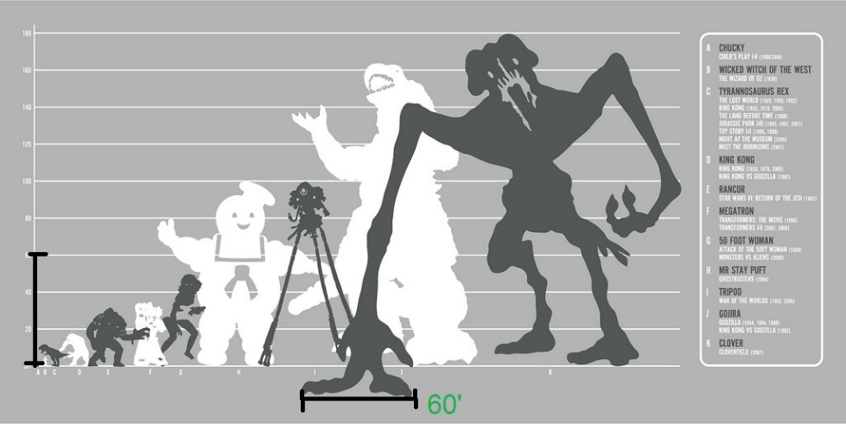
What makes a monster? Also, look how cute the Stay Puft Man is,
surrounded by his ugly monster friends.
Outcomes Targeted: One, Two, and Four
So far, I’ve covered two theses from Jeffrey Jerome Cohen’s Monster Theory: Reading Culture : Monster Thesis One and Monster Thesis Seven. Now, we’re going to use Dracula as a starting point for processing the remaining five theses, which speak to our course questions and provide a helpful theoretical framework for all monster texts. To make processing this theoretical text easier, we’ll be dividing it into portions for small groups to present on to the class.
Your Task
As a group, summarize your monster thesis, put it in conversation with Dracula (apply the thesis, discuss how it occurs in the text and where), and then pull from outside examples to provide further application of the thesis. Your outside examples should be other monsters (from literature, film, comics, etc.) that you think illustrate Cohen’s point.
These are the sections of Cohen’s text that each group is responsible for (note that I will assign groups):
- Group One: Monster Thesis Two and Three
- Group Two: Monster Thesis Four
- Group Three: Monster Thesis Five
- Group Four: Monster Thesis Six
Remember, I will be assessing you based on the effectiveness of your presentation; a strong presentation will clearly communicate the meaning of the thesis in a way that’s understandable for the rest of the class. You can quote Cohen in your presentation, but you all should come to a consensus on how to summarize or paraphrase Cohen so that the thesis’s meaning is clear and concise. While concision is important, your summary should still be representative of the whole thesis. For example, if I were to summarize Monster Thesis One as “The monster’s body is a culture’s fear,” my summary would ignore that the monster’s body can take on many other cultural meanings according to Cohen—desire, hope, anxiety, etc.
A strong presentation will also make an effort to not be boring (not joking, y’all, good rhetoric means being engaging) and consider what features your presentation could use in applying the thesis. Do you want to use visuals, like images or clips? How much context do you need to provide for the class to understand why your outside examples are relevant? It might be helpful to think of this assignment as teaching your classmates your assigned Monster Thesis.
Format: Your presentations should be at least ten minutes long, no longer than fifteen minutes. One group member should submit a copy of the presentation (a PowerPoint, a notes page, etc.) to Canvas.
Due Date: The dates for each presentation are listed on the syllabus.
We’ll talk about this more in class! If you have any questions, either as an individual or as a group, you can always contact me through email or during my office hours.

Short Assignment One: Comparative Analysis
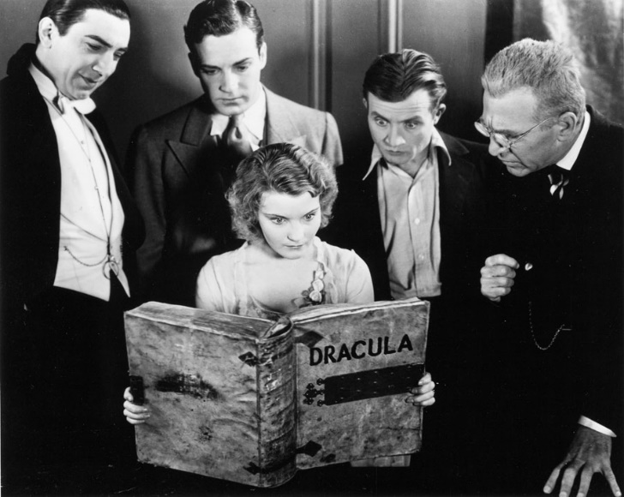
How meta is this old promotional photo??
Outcomes: 1, 2 ; SA #1 Rubric Class Annotation.docx
So far in this class, we’ve developed a working knowledge of genre, how to analyze visual and textual rhetoric, and the shifts in rhetorical situation that occur when a text or monster undergoes a drastic change. Now, you’ll use these skills to compare and contrast the textual and visual features used in two versions of Dracula.
Your Task
For this assignment, you will analyze Dracula to identify the textual features that Bram Stoker uses to build a specific stance on a prevalent and critical theme (a complex claim). You will then compare how an adaptation of Dracula tackles this same theme. You might begin the brainstorming process with these questions:
- What are major themes, concepts, or thoughts present in the text that interest you?
- What does the text say about this idea or theme? Make sure your claim is complex!
- What is the context behind this novel?
- In general, throughout the text, where does the creator spend time exploring this theme or offering a stance on this theme?
Remember the 3-step process of turning a big theme into a complex claim by considering its stakes:
- Identify a big focus or a general theme
- Start asking questions about how the theme interacts within the text itself, with different perspectives and characters! What perspective on this theme exists in the text?
- Turn your answers to those above questions into a declarative statement that you can prove with evidence from your text!
You should then pick one specific scene, character description, or setting description where the claim you’ve identified is built (or partially built!) in both Dracula and an adaptation of Dracula. The choice of adaptation is completely up to you. You will compare and contrast the textual and visual features used by both texts to create their responses to the claim you've identified. It's okay if your texts take different perspectives on your theme! It's also okay if the scenes you're analyzing aren't completely the same. You're looking for a space that creates natural comparisons, not for an adaptation that is a shot-for-shot remake of the novel.
Questions that could be helpful as a starting point for analysis include:
Here are some questions that you could engage with in your paper (remember, this is not an outline for your paper! You need to determine your own organizational structure!):
- What features does this adaptation of the Dracula use in this scene to create and reaffirm its claim? Visual? Textual? (This can include dialogue!)
- Has the audience changed during the adaptation process? How does this affect the rhetoric used?
- What has the change in genre strengthened in or expanded from the source text to the adapted text? What has the genre shift weakened or limited?
- Has the context between the two versions shifted? In what way?
- What concepts from the film analysis sheet appear in this scene? What affect do they have on the theme? On the audience?
Rhetorical Situation/Audience: Your peers and myself. The genre of this assignment is an academic essay, so your tone should be formal but engaging. For this assignment, you can use the first person, but remember to frame your writing as an analysis, not as an opinion! Unlike a traditional essay that you've learned in high school, you can use images to help illustrate your points. We'll talk about ways to incorporate and format images in class.
A successful paper will also include specific examples and direct quotations from both texts. These detailed examples will also be connected to questions of how and why the strategies connect to the claim you’ve identified. I don't want you just to explain the differences in plot for the adaptation. While plot information might be helpful context, do not let it overwhelm your paper. I'm looking for analysis. Finally, a successful paper will also have an introduction, a conclusion, and a kickass title.
Format: Times New Roman, 12 pt. font, double spaced, 1-inch margins. 3 pages.
DUE DATE:
Peer Review Due:

Short Assignment Two: Synthesis and Genre
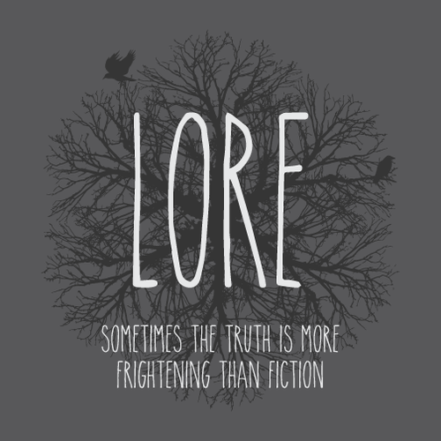
↑ And sometimes writing is more frightening than both (but not today (I mean it))
Outcomes: 1, 2, 4 SA #2 Rubric
According to Cohen’s Monster Thesis I, the monster’s body is a cultural body, in that it embodies a culture’s “fear, desire, anxiety, and fantasy” (4). His second thesis posits that “Monsters must be examined within the intricate matrix of relations (social, cultural, and literary-historical) that generate them” (5). In Aaron Mahnke’s podcast Lore, he dedicates many episodes—including “The Beast Within”—to exploring the folklore origins of a specific monster, creature, or fear. “The Beast Within” explores the history behind werewolves and then tells the story of one specific werewolf haunt. Now that we’ve explored a few monsters as a group, I’m asking you to choose a monster and trace a portion of its history to construct a small portion of that monster’s “matrix of relations.”
Your Task
Provide historical context on a monster of your choosing and present this information through a podcast script.
Using at least three sources (one of which must be found through the library database), you should create a brief overview of your monster—what it is, where its origins are, and where it has appeared throughout history. To do this, you will need to develop your summary, synthesis, and research skills.
While creating your podcast script and researching your monster, keep these questions in mind (note that these are not a step-by-step roadmap for your paper!):
- Why does your audience know this monster? Have they seen versions of this monster in contemporary culture, or are you introducing a totally new monster to them?
- What’s the first recorded (written down) story or myth your monster appears in? Does your monster have an oral tradition that occurs before that?
- Is your monster specific to a certain culture? Or do versions of your monster occur globally, in different traditions?
- Like “The Beast Within,” do you want to pay particular attention to a dramatic or compelling historical moment involving your monster, or perhaps a particularly famous fictional story your monster appears in? Or would you rather give a broad overview?
- Based on its history, what cultural fears, desires, or anxieties might your monster represent? How might you apply Cohen’s first two theses?
Your Rhetorical Situation/Audience (the context for your assignment):
This is not an essay. I’m not asking you to record your podcast, but your project should not read like a five paragraph essay. We’ll discuss in class what the general format for a podcast script should look like, but this could vary based on your choices as a writer; for example:
- How many speakers are there? Is it just you narrating the podcast, or do you have two (or more!) speakers? How do you interact together?
- What music do you imagine plays during your podcast? When should you provide breaks for your listener to affect the tone or how they process the information you’ve given them? Note music breaks or music cues in your podcast!
- Who is your target audience?
When writing your summary, you should be thinking about the podcast genre. How can your tone, word choice, pacing (how long you spend on certain content, how quickly you introduce new information) best reach someone through this genre? How can you best engage your audience and make them want to listen to your podcast?
Your podcast can use “The Beast Within” as a model; your podcast script should include elements that we’ve identified in-class together.
Format: Times New Roman, 12 pt. font, double spaced, 1-inch margins. Total 2-3 pages.
Citation Instructions: You will provide a works referenced page at the end of your paper using MLA citation formatting. While you should not often be quoting from your sources, be careful to avoid accidental plagiarism. Be thoughtful if you are paraphrasing and provide in-text citations when needed.
PEER REVIEW DATE:
DUE DATE:
We’ll discuss this assignment more in class! Feel free to contact me with any questions in-person or by email; my office hours are listed on the syllabus.

Major Project: Adaptation and Argument
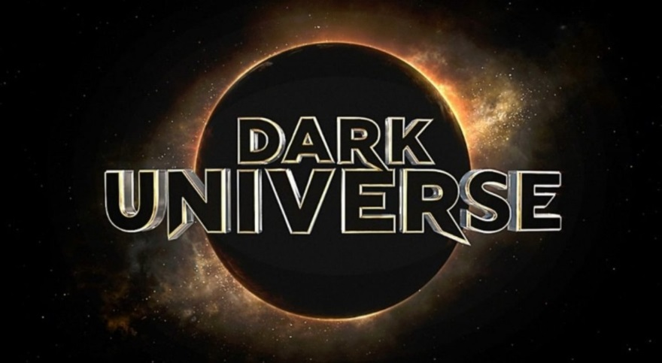
↑ A comfort: whatever you create for this assignment will 1) Be better than the hot mess that is Universal’s Dark Universe 2) Have a lot less Tom Cruise in it
Outcomes: 1, 2, 3, 4, Rubric
Actions
So far in this course, we’ve learned about genre and genre conventions, practiced writing within a genre, identified audiences and purposes, and learned how to research and build a history around a subject (Podcast Assignment). We’ve also performed close readings to identify themes and rhetorical techniques in texts (of varying genres) and started forming complex claims about a text’s thematic content (Dracula assignments). Throughout the quarter, we’ve learned some tenants of monster studies and talked about shifts in rhetorical situations/triangles between original texts and adaptations.
Now, I’m asking that you create a piece of writing that engages all of our course’s outcomes and demonstrates your ability to write a piece of significant length; this will be an extended project in which you hone the above skills to persuasively present an adaptation of your own making.
Your Task
Your project will be comprised of multiple parts that culminate in a large piece of writing. Your task is to pitch an adaptation of a source text to an appropriate publisher, director, film studio, comic studio, etc.; your pitch will include a formal letter that argues why you’re qualified to undertake this adaptation, why you’ve made certain rhetorical and creative choices in your adaptation, and why your adaptation will be successful. Your pitch will also include one (optional two) adaptation artifact(s).
You can choose a monster or text from our syllabus, or you can choose a monster from another text. You must adapt a specific text that centers around a monster. You cannot adapt a general concept of a monster or a general history of a monster. For example, you could adapt “Cue: Change” into a television show pitch, but you could not adapt zombies as a general concept. You could adapt Night of the Living Dead, but you could not adapt zombies as a general concept. Your original text can be any genre, it’s not limited to novels or short stories, but your adaptation must be noticeably distinct from its original in some aspect of its rhetorical situation or genre.
The components of the project in its full are as follows:
- Proposal
- Review of Your Source Text
- Pitch to your publisher **Submitted Here**
The largest portion of your project will be your pitch letter to a publisher, producer, or director. You should research a specific recipient for this letter. Examples would include film studios like Marvel, Universal, Warner Brothers; directors whose aesthetics or directorial style you think would suit your vision well; comic companies; record labels; producers likely to invest in your adaptation; book publishing companies; etc.
Your pitch letter should be 5-6 pages if you’ve decided to create one adaptation artifact, or 4-5 pages if you’ve chosen to create two artifacts. Your pitch letter should:
Reference your close analysis of the original text; how is its complex claim and purpose communicated in your adaptation?
Refer to your adaptation artifact and explain how its genre and its conventions lend itself to your creative vision for your adaptation or to elements of the original text
Reference three to five outside sources (IE: not your original text)
  - These should be articles, interviews, statistical information (like box office figures), etc. that build your credibility and help you argue why your adaptation should be made.
Breakdown the rhetorical situation surrounding both the original text and your adaptation
Create a strong, persuasive argument that your reader should greenlight, publish, or fund your adaptation; to do this, you should use a thoughtful mixture of rhetorical appeals (we’ll cover these in class)
Showcase your understanding of your original text’s monster, its theme, its rhetorical techniques, and perhaps its connections to Cohen’s Monster Theses
- Adaptation artifact(s) **Submitted Here**
Your adaptation artifact should showcase your actual adaptation. This could be the entirety of your adaptation if your genre is particularly short, like song lyrics, or it could be an excerpt, a detailed outline, a casting list, a prop, a scene from a screenplay, a graphic novel’s concept art, a cookbook, a webseries, etc. Be creative here! Again, your artifact should differ in some substantial way from your original text!
You need at least one artifact, but if you create two, your letter can be shorter (see above).

\Your Rhetorical Situation/Audience (the context for your assignment):
You will choose your own publisher for your adaptation, but across the board, your letters should be formal, business-professional in tone, and formatted as a letter. Your artifacts will vary in rhetorical situation based on the genre of your adaptation, your intended audience, your purpose, and the context of your adaptation. These elements, while they’re your choice, should be consistent.
Format:
Your letter should be formatted like a business letter, but with full MLA citations. This will include in-text citations as well as a Works Cited page. Your letter should be Times New Roman, 12 pt font, double spaced, with 1-inch margins.
ROUGH DRAFT DUE/ PEER-REVIEW DATE:
Mini-Presentation and FINAL DUE DATE (Canvas submission):
As part of this assignment, you will present a brief overview of your pitch letter and your adaptation artifacts to your peer-review group as if they’re the ones green-lighting your adaptation. I’ll explain this in further detail leading up to the presentation, but know that these are fairly laid back, and you won’t be presenting in front of the entire class. This is more intended to be a practice for future presentations in other classes and the ability to distill larger projects into concise presentations.
Your final draft will include revised versions of your pitch letter and your adaptation artifact(s). Your book review and proposal do not need to be revised; rather, they can be repurposed into your letter.
We’ll discuss this assignment much more in class and will pace this out over the remainder of the quarter! Feel free to contact me with any questions in-person or by email; my office hours are listed on the syllabus.

SA #3: Major Project Proposal
Often in your academic and future careers, you'll be asked to submit a proposal; you might be proposing a new project, a paper, a shift in business operations, a campaign. Proposals can have different audiences and different requirements, but they all have the same general purpose: to give context and to convince the reader that what you're proposing will successfully accomplish its goal.
Your Task
For your major project, you will create a 1 page proposal that introduces me to:
- The text you plan on adapting
- Why you’ve chosen to adapt this text
- The genre you'll be adapting the text into and why
- Why it's compelling: what are the big themes you think are present in the text, or why do you think the monster is compelling culturally?
- Where your research for this project might start (what secondary sources would you need?). For example, a project that proposes to adapt Tom Cruise's The Mummy will probably need a source that discusses why the movie is promising in spite of it being a flop, or a source that shows other films featuring mummies have grossed more money, etc. Think of what the strengths and weaknesses of your text are, and how you can highlight or compensate for those in your pitch letter.
In order to have a successful proposal, you should be rereading the MP prompt carefully!
Rhetorical Situation
Your tone is formal and academic, and you should also be persuasive! Convince me that this project will be successful and compelling! You should also hook me in at the beginning by having an engaging first sentence! Think of your opening the same way you would think of an introduction: it should draw your reader in. Proposals are also short! The page maximum is a convention of the genre. Going over a page means that your proposal is less successful!
Sample proposals are available on Canvas. Your project can change after your proposal, but ideally your proposal will reflect your later project.
Due:
As always, you can email me with any questions or concerns.
Short Assignment Four: Major Project Review
Your Task
You will write a 1.5 - 2 page review of your source/original text (not your adaptation! The text you are adapting!). In this review, you will identify a complex claim in your source text and map the rhetorical situation of your source text. Your review should ask/develop the following:
- What do you believe to be a major theme or focus created by the text? Develop a complex claim about this text’s approach or purpose in relation to this theme!
- What are the stakes of this complex claim: why does it matter?
- Identify a single significant passage/scene from the work that acts as textual support for your theme, and analyze why it's successful or unsuccessful
Rhetorical Situation/Audience:
Since you're writing in the review genre, you can choose to be as formal or informal as you'd like in this assignment; reviews come in all levels of formality. However, you should have an engaging opening and conclusion that helps grab your reader's attention, and you will want to weigh in on whether or not you think the text is worth watching or reading. You could even rank it on a scale of 1-5 stars! Consider who would be reading your review, and let that guide how formal you are.
Your review should follow this general format:
- An Introduction
- Body (might be more than one paragraph)
- Conclusion: Consider the stakes of your text and its claim (why does the text matter), and in review-fashion, answer this question: who would you recommend this text to, and why?
DUE:
As always, never hesitate to email me with any questions!

